|  |  |
| --- | --- |
| **Name** | Faizan Azam, Muhammad Asad, Asad-ur-Rehman |
| **Reg. No** | 2019-EE-381, 383, 389 |
| **Marks/Grade** |  |

# Objective:

**EXPERIMENT # 6**

**Under Voltage and Overvoltage Relay in HV Lines.**

At the end of this lab session students will be able to

* Use De Lorenzo power system Protection kits.
* Implement Under voltage & Overvoltage by using De Lorenzo power system Protection kits.
* Relay behaviour in three phase systems for Under Voltage,Over Voltage by changing load.
* Determination of resetting ratio.

# Introduction:

A relay is usually an electromechanical device that is actuated by an electrical current. The current flowing in one circuit causes the opening or closing of another circuit. Relays are like remote control switches and are used in many applications because of their relative simplicity, long life, and proven high reliability. Relays are used in a wide variety of applications throughout industry, such as in telephone exchanges, digital computers and automation systems. Highly sophisticated relays are utilized to protect electric power systems against trouble and power blackouts as well as to regulate and control the generation and distribution of power. In the home, relays are used in refrigerators, washing machines and dishwashers, and heating and air-conditioning controls.

Although relays are generally associated with electrical circuitry, there are many other types, such as pneumatic and hydraulic. Input may be electrical and output directly mechanical.All relays contain a sensing unit, the electric coil, which is powered by AC or DC current. When the applied current or voltage exceeds a threshold value, the coil activates the armature, which operates either to close the open contacts or to open the closed contacts. When a power is supplied to the coil, it generates a magnetic force that actuates the switch mechanism

# Apparatus:

* 1DL 7901TT Overhead Line model
* 1DL 2108T12 Under/Over voltage relay
* 1 DL 2109T3PV Moving iron Voltmeter
* 1 DL Buz Acoustic continuity tester
* 1 DL 1017R Resistive Load
* 1 DL 1080TT Three phase transformer
* 1 DL 2108TAL-SW Three Phase power Supply

# Under Voltage and Overvoltage Relay:

For the satisfactory working of all [electrical and electronic devices,](https://www.elprocus.com/basic-components-used-electronics-electrical/) it is recommended to allow voltage at prescribed limits. Voltage fluctuations in electric power supply certainly have adverse effects on connected loads. These fluctuations can be of over voltage and under voltages which are caused by several reasons like voltage surges, lightning, overload, etc. Over voltages are the voltages that exceed the normal or rated values which cause insulation damage to electrical appliances leading to short circuits. Similarly, under-voltage causes overloading of the equipment leading to lamp flickers and inefficient performance of the equipment. This voltage protection circuit is designed to develop a low-voltage and high-voltage tripping mechanism to protect a load from any damage. In many of the homes and industries fluctuations in AC mains supply take place frequently. The electronic devices get easily damaged due to fluctuations. To overcome this problem, we can implement a tripping mechanism of under / overvoltage protection circuit to protect the loads from the undue damage.

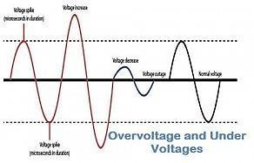Thus, this article is intended to give [under and overvoltage protection circuit](https://www.elprocus.com/voltage-electrical-short-circuit-prevention/) schemes with different control structures.

**VM:** Maximum set point, have dial to set % of nomial voltages from 0 to +20%

**Vm:** Minimum set point, have dial to set % of nomial voltages from 0 to -20%

**Vn:** Dial is available for nomial voltage three phase system to select from available (380V)

**TM**: Dial is available for setting delay time for over voltage conditions **Tm:** Dial is available for setting delay time for under voltage conditions **HV transmission Lines:**

High-voltage transmission lines are used to transmit electric power over relatively long distances,

usually from a central generating station to main substations. They are also used for electric power transmission from one central station to another for load sharing. High voltage (HV) transmission

lines are made of high voltage (between 138 and 765 kilovolts) overhead and underground conducting lines of either copper or aluminum.

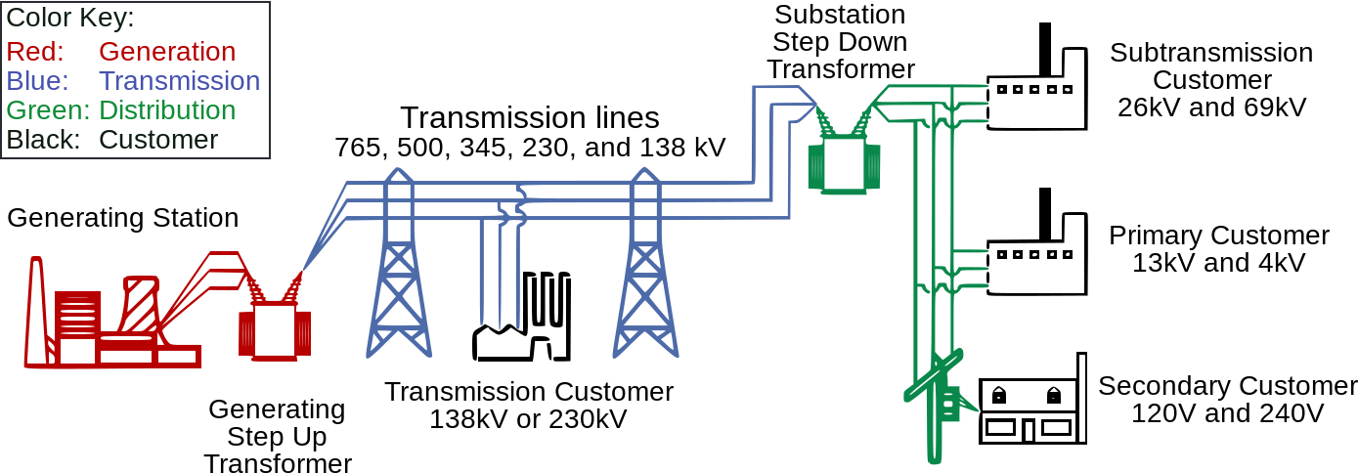

# Indications:

ON : Green LED, supply on

AM: Red LED, set point VM has reached Am: RED LED, set point Vm has reached

## Under Voltage & Over Voltage Time Relay Basic Diagram:

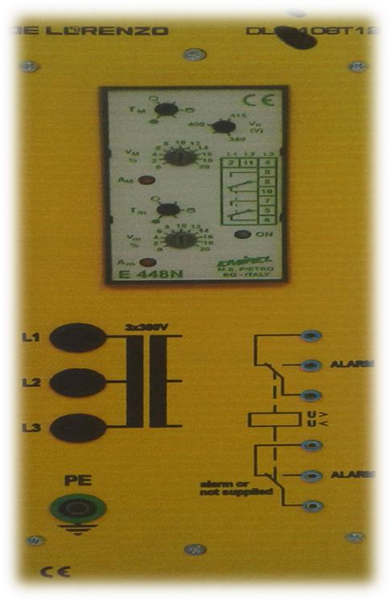

**Figure 1 : VT internal wiring Diagram**

## Circuit construction:

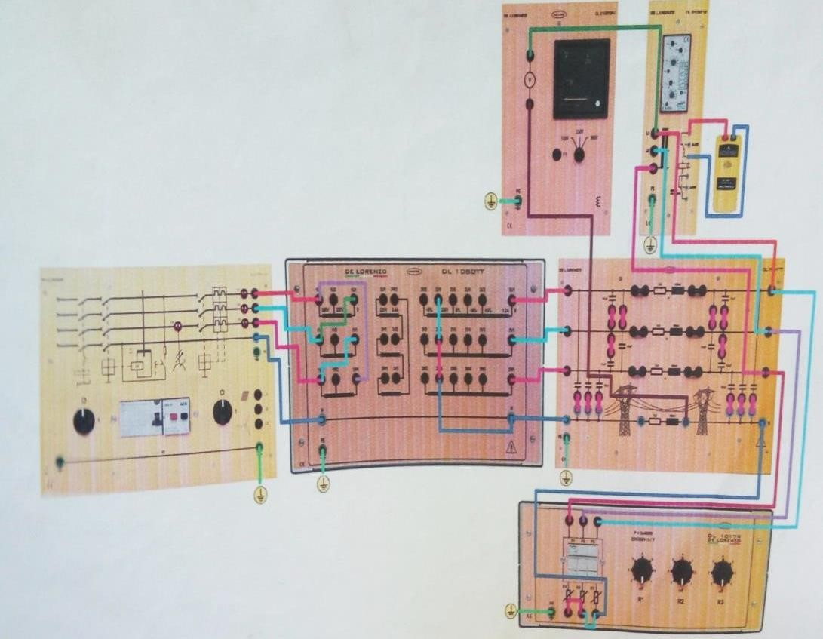

**Procedure:**

* Connect circuit as shown in Fig 2.
* Set three phase power supply voltage 380v and relay is not in operation
* Observe over voltage reference voltage w.r.t to three phase supply and set load at R4.
* Slowly decrease Load and observe overvoltage condition.
* Observe Over voltage reference voltage w. r .t to three phase supply.
* Slowly increase Load and observe under voltage condition.
* Observe Under voltage reference voltage w. r .t to three phase supply.
* Apply same procedure for different timer conditions

# Table:

|  |  |  |  |  |  |  |  |
| --- | --- | --- | --- | --- | --- | --- | --- |
| **Over Voltage conditions** | | | | **Under Voltage conditions** | | | |
| **Load position** | **VL**  **Measured** | **VL**  **Calculated**  𝟏∅ | **Trip Condition** | **Load position** | **VL**  **Measured** | **VL**  **Calculated**  𝟏∅ | **Trip Conditi on** |
| 2 | 259.7 | 223.78 | 12% | 5 | 215.2 | 208.42 | 12% |
| 3 | 245.4 | 221.58 | 10% | 6 | 209.8 | 206.22 | 10% |
| 4 | 238.6 | 228.16 | 8% | 7 | 201.3 | 204.03 | 8% |

## Lab performance:

**Over voltages condition at load 3rd positions:**

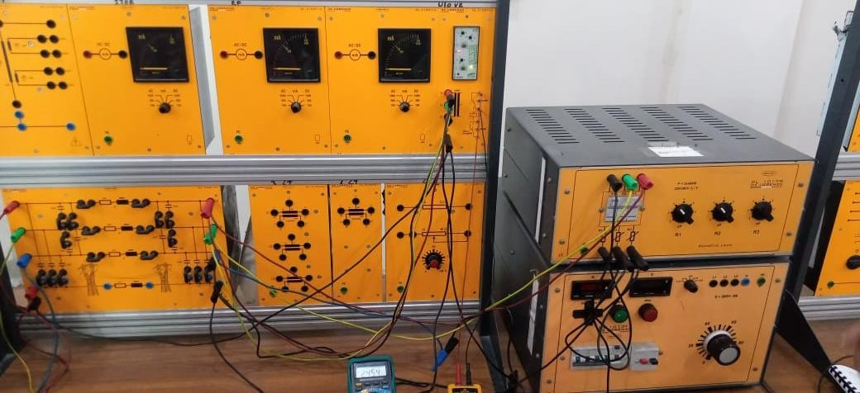

**Under voltage condition at load 5th position:**

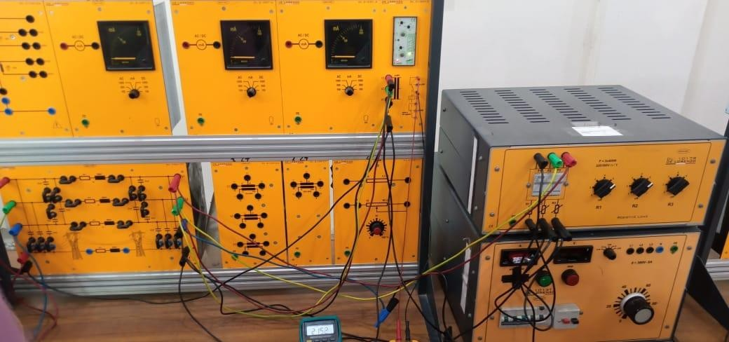

**Over voltage condition at load 2nd position:**

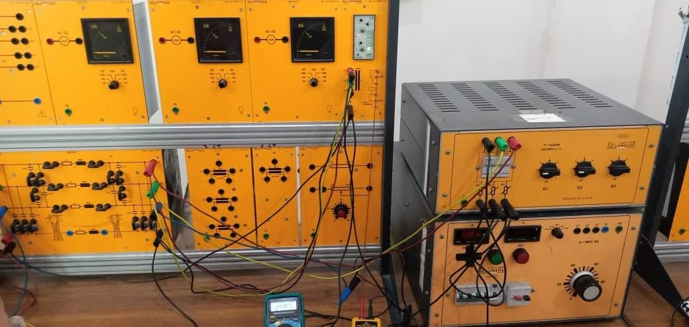

**Under voltage condition at load 6th position:**

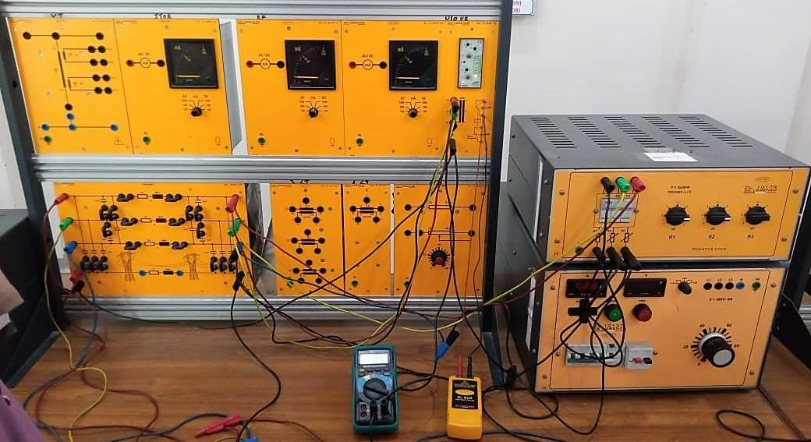

**Normal condition at load 5th position:**

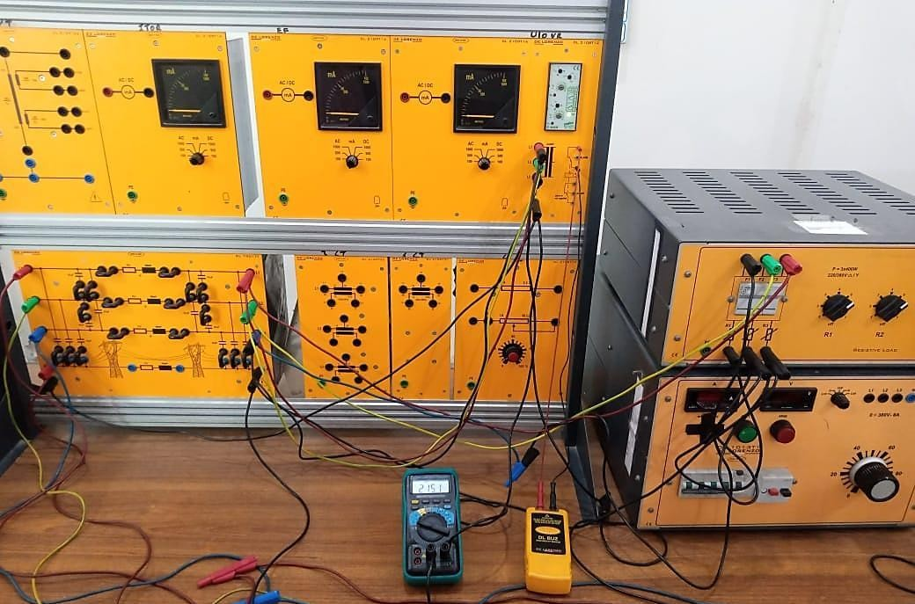

**Normal condition at load 4th position:**

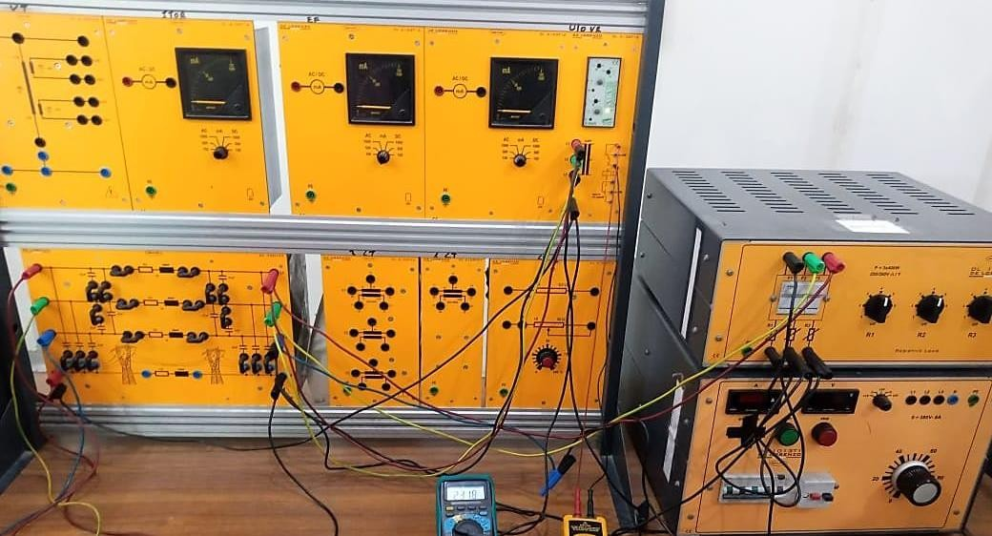

**Observation:**

In this lab, we implement under voltage & Overvoltage by using De Lorenzo power system Protection kits. We observe two voltage condition: ¬ Undervoltage occurs when the voltage drops below the intended level which could be dreadful for electronic devices to operate properly. ¬ Overvoltage occur when voltage exceed the set point value, which also harmful for devices and also cause severe damage. To observe above two phenomena’s, we perform this experiment for protection of high voltage transmission line which deliver electricity on long distances. We used a fix three phase voltage supply of transformer ratio 1:1 with variable load. We set both relay on zero point and determine the set point voltage for relay operation. Slowly, we increase voltages and we observe that when voltage exceed the upper limit then over voltage relay operates by showing indication via red led. And when voltage decrease below a certain value then undervoltage relay operates. Then we observe the operation of under voltage and over voltage relay for different relay setting. We also observe that the error ratio between measured and calculated values of both relays is less than 1. We conclude that by using undervoltage and overvoltage relay, we can protect our HV transmission line from a severe damage by knowing about fault at right time. We also protect the load devices connected to these lines